Literacy support worksheet

5.1 Classification organises our world

Pages 80–81 and 192

Classification history

In the 4th century, the Greek philosopher Aristotle classified all living things into two groups: plants and animals. His collection of ‘animals’ included giraffes, dragonflies and sharks. He divided these animals into three new groups based on how they moved: walking (land), flying (air) or swimming (water).

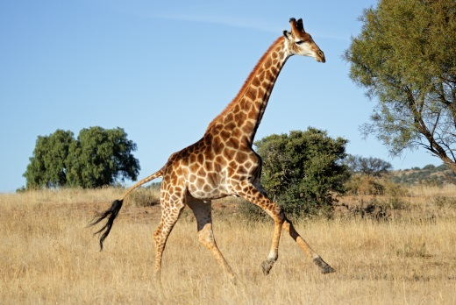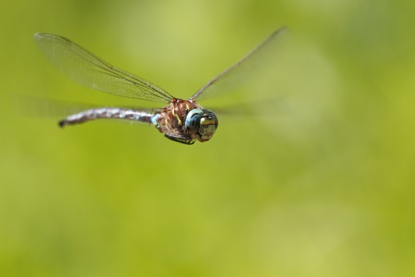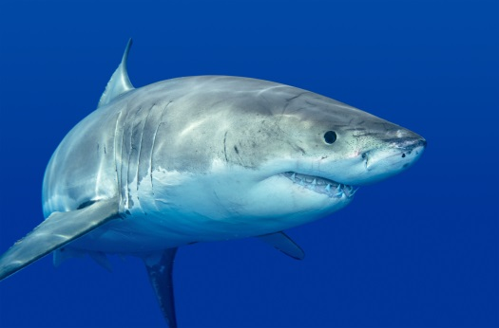

1 Name two animals that would fit into the following groups:

a Walking \_\_\_\_\_\_\_\_\_\_\_\_\_\_\_\_\_\_\_\_\_\_\_\_\_\_\_\_\_\_\_\_\_\_\_\_\_\_\_\_\_\_\_\_\_\_\_\_\_\_\_\_\_\_\_\_\_\_\_\_\_\_

b Flying \_\_\_\_\_\_\_\_\_\_\_\_\_\_\_\_\_\_\_\_\_\_\_\_\_\_\_\_\_\_\_\_\_\_\_\_\_\_\_\_\_\_\_\_\_\_\_\_\_\_\_\_\_\_\_\_\_\_\_\_\_\_

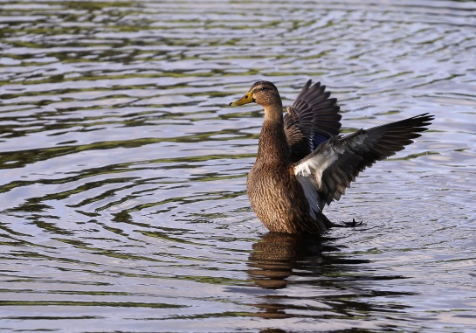c Swimming \_\_\_\_\_\_\_\_\_\_\_\_\_\_\_\_\_\_\_\_\_\_\_\_\_\_\_\_\_\_\_\_\_\_\_\_\_\_\_\_\_\_\_\_\_\_\_\_\_\_\_\_\_\_\_\_\_\_\_\_\_\_

2 In which of Aristotle’s group would a duck belong? Explain why.

3 In which of Aristotle’s groups would a frog belong? Explain why.

4 According to Aristotle, both bats and birds would be in the ‘flying’ group. Suggest a reason why these two animals should not be classified in the same group.

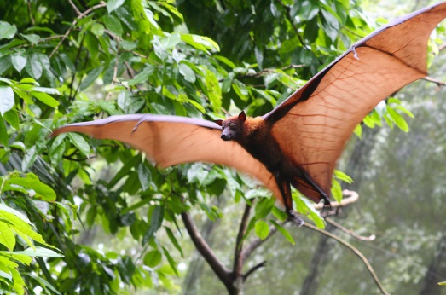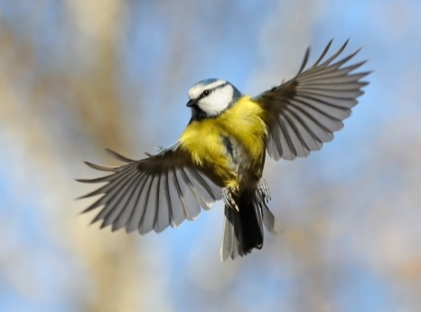

Carl Linnaeus designed the current system of classification in the 18th century.

5 Why do you think Linnaeus made changes to the classification system?

WORD DETECTIVE

6 Draw and label

Draw, label and illustrate a classification key that shows how Aristotle classified living things.

|  |
| --- |
|  |

Literacy support worksheet

5.2 Living organisms have characteristics in common

**Student worksheet**

Pages 82–83

Living or non-living?

In biology, we start to classify the things in the world according to whether they are living or non-living. Living things have special features that make them distinctly different from non-living things

1 All living things share eight key features. Complete the mnemonic (memory trick) below to outline the meaning of each feature. The first one has been done for you.

|  |  |
| --- | --- |
| M | Movement: Living things can MOVE by themselves |
| R |  |
| N |  |
| G |  |
| R |  |
| E |  |
| W |  |
| W |  |

2 Are the following things **living** or **non-living**? Write your answers below. The first one has been done for you.

|  |  |  |  |  |  |
| --- | --- | --- | --- | --- | --- |
| a | a cat | living | e | salt | \_\_\_\_\_\_\_\_\_\_\_\_\_\_\_\_\_\_\_\_\_\_\_ |
| b | a drop of water | \_\_\_\_\_\_\_\_\_\_\_\_\_\_\_\_\_\_\_\_\_\_\_ | g | bacteria | \_\_\_\_\_\_\_\_\_\_\_\_\_\_\_\_\_\_\_\_\_\_\_ |
| c | an ant | \_\_\_\_\_\_\_\_\_\_\_\_\_\_\_\_\_\_\_\_\_\_\_ | h | grass | \_\_\_\_\_\_\_\_\_\_\_\_\_\_\_\_\_\_\_\_\_\_\_ |
| d | mould | \_\_\_\_\_\_\_\_\_\_\_\_\_\_\_\_\_\_\_\_\_\_\_ | i | computer | \_\_\_\_\_\_\_\_\_\_\_\_\_\_\_\_\_\_\_\_\_\_\_ |

3 Light a candle and look at the candle flame. Describe how it carries out each of the eight key features.

|  |  |
| --- | --- |
| M | Movement: The flame flickers and moves |
| R |  |
| N |  |
| G |  |
| R |  |
| E |  |
| W |  |
| W |  |

4 Look at your answers to the questions above. Do you think a flame is living or non-living? Why?

WORD DETECTIVE

5 Word Search

Find the words listed in the puzzle below.

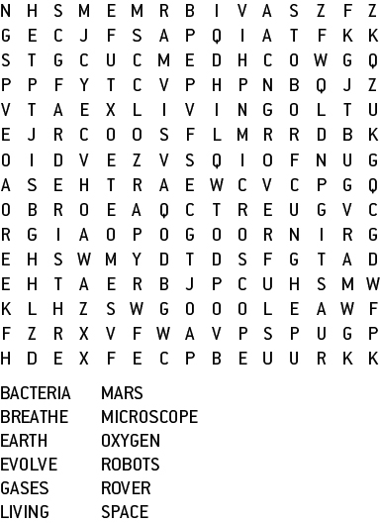



Literacy support worksheet

5.3 Classification keys are visual tools

Pages 84–85 and 193

Who am I?

1 What is a dichotomous key?

2 Why do scientists use dichotomous keys?

4 On the next page is a dichotomous key for students in a Science class at *Stickman Secondary College.*

a Use the dichotomous key provided to identify the students in this class at *Stickman Secondary College* on the following page.

b Draw the missing students.

WORD DETECTIVE

4 Word search

Find as many words as possible in the puzzle below.

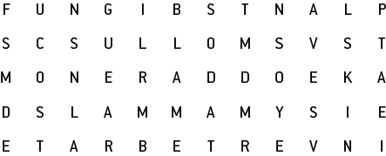

**Dichotomous key for students in a Science class at *Stickman Secondary College***

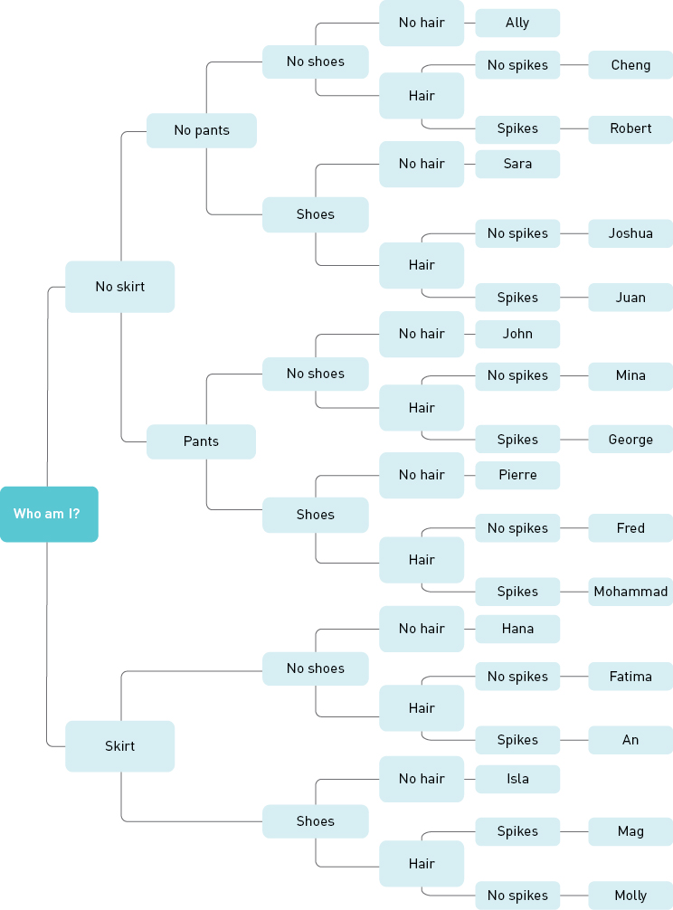

|  |  |  |  |  |  |
| --- | --- | --- | --- | --- | --- |
| A  WS0534_00876  \_\_\_\_\_\_\_\_\_\_ | B  WS0528_00876  \_\_\_\_\_\_\_\_\_\_ | C  WS0531_00876  \_\_\_\_\_\_\_\_\_\_ | D  WS0530_00876  \_\_\_\_\_\_\_\_\_\_ | E  WS0536_00876  \_\_\_\_\_\_\_\_\_\_ | F  WS0533_00876  \_\_\_\_\_\_\_\_\_\_ |
| G  WS0535_00876  \_\_\_\_\_\_\_\_\_\_ | H  WS0527_00876  \_\_\_\_\_\_\_\_\_\_ | I  WS0538_00876  \_\_\_\_\_\_\_\_\_\_ | J  WS0529_00876  \_\_\_\_\_\_\_\_\_\_ | K  WS0537_00876  \_\_\_\_\_\_\_\_\_\_ | L  WS0532_00876  \_\_\_\_\_\_\_\_\_\_ |
| M  \_\_\_\_\_\_\_\_\_\_ | N  \_\_\_\_\_\_\_\_\_\_ | O  \_\_\_\_\_\_\_\_\_\_ | P  \_\_\_\_\_\_\_\_\_\_ | Q  \_\_\_\_\_\_\_\_\_\_ | R  \_\_\_\_\_\_\_\_\_\_ |

Literacy support worksheet

5.4 The classification system continues to change

Pages 86–87 and 194

Classification using seven levels

All living things on Earth can be classified using a classification system with 7 levels:

1 Kingdom

2 Phylum

3 Class

4 Order

5 Family

6 Genus

7 Species

The largest grouping is the kingdom. The smallest grouping is the species.

This worksheet will help you to learn how scientists classify different plants and animals.

|  |  |  |  |  |  |  |
| --- | --- | --- | --- | --- | --- | --- |
| 1 Kingdom | Animalia | Animalia | Animalia | Animalia | Animalia | Animalia |
| 2 Phylum | Chordata | Chordata | Arthropoda | Chordata | Chordata | Chordata |
| 3 Class | Mammalia | Mammalia | Insecta | Reptilia | Aves | Actinopterygii |
| 4 Order | Primates | Carnivora | Hymenoptera | Squamata | Galliformes | Scorpaeniformes |
| 5 Family | Hominidae | Felidae | Apidae | Varanidae | Phasianidae | Scorpaenidae |
| 6 Genus | Homo | Uncia | Apis | Varanus | Pavo | Pterois |
| 7 Species | sapiens | uncia | mellifera | varius | cristatus | antennata |
| Common name | Human | Snow leopard | Honey bee | Lace monitor | Peacock | Lionfish |

1 Which level of classification (in grey) do you think contains the largest number of organisms?

2 Which level do you think contains the smallest number of organisms?

3 Which two species in the table above would be most similar? Explain why.

4 Which organism listed in the table above is most different to all the other organisms?

WORD DETECTIVE

5 Mumbo-jumbo

a Use the marked letters to find the secret word (e.g. olusntoi = solution).

b Unscramble each of the clue words below to find the message.

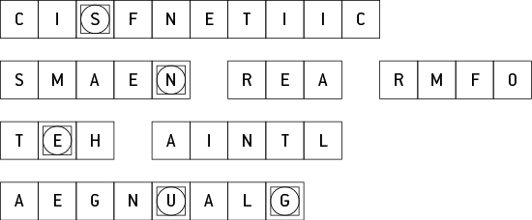

S

Message: \_\_\_\_\_\_\_\_\_\_\_\_\_\_\_\_\_\_\_\_\_\_\_\_\_\_\_\_\_\_\_\_\_\_\_\_\_\_\_\_\_\_\_\_\_\_\_\_\_\_\_\_\_\_\_\_\_\_\_\_\_\_\_\_\_\_\_\_\_\_\_\_\_

Secret word: \_\_\_\_\_\_\_\_\_\_\_\_\_\_\_\_\_\_\_\_\_\_\_\_\_\_\_\_\_\_\_\_\_\_\_\_\_\_\_\_\_\_\_\_\_\_\_\_\_\_\_\_\_\_\_\_\_\_\_\_\_\_\_\_\_\_\_\_\_\_\_

Literary support worksheet

5.5 All organisms can be divided into five Kingdoms

Pages 88–89 and 195

Kingdoms of life

The largest groupings in the classification system are the kingdoms. Features such as body form, type of cells and methods of obtaining nutrients are used to classify living things into groups.

| Kingdom | Body form and movement | Getting food | Examples | Number of known species |
| --- | --- | --- | --- | --- |
| Animalia | Multicellular with specialised eukaryotic cells. | Heterotrophic | Mammals, birds, reptiles, fish, amphibians, insects, worms, sponges | 9 812 298 |
| Plantae | Multicellular with specialised eukaryotic cells. Cells have a cell wall made of cellulose. | Autotrophic | Trees, flowering plants, conifers, mosses, ferns | 320 000 |
| Fungi | Multicellular, usually, with specialised eukaryotic cells. Cells have a cell wall made of chitin. | Heterotrophic | Fungi, moulds, mushrooms, yeasts, mildews | 1 500 000 |
| Monera | Tiny single-celled organisms with prokaryotic cells. Some form chains or mats or colonies. | Heterotrophic; a few are autotrophic | Bacteria, blue–green algae | 1 000 000 |
| Protista | Small single-celled organisms with a eukaryotic cell. Some form chains or colonies. Usually found floating in water. | Heterotrophic or autotrophic | Algae, amoebas, plankton, protozoans | 600 000 |

1 List the five main kingdoms.

2 Which of the kingdoms has the smallest number of known species?

3 Which two kingdoms are made up of single-cell organisms?

4 How are members of the Plantae kingdom different to all other life forms?

5 Which of the kingdoms would be the most successful type of life form on Earth? Explain, giving reasons.

WORD DETECTIVE

4Match a Word

Draw a line from the word to the description.

UnicellularOrganisms that don’t fit in the other kingdoms fit here

NucleusAll organisms are multicellular, but don’t have a cell wall

Cell wallHas a cell nucleus, but doesn’t make its own food

Kingdom FungiAll organisms are multicellular and have a cell wall

Kingdom AnimaliaThe building blocks of life

Kingdom PlantaeThe body in the middle of a cell

Kingdom ProtistaHas only one cell

CellsThe wall around the cell

Literacy support worksheet

5.6 Animals that have no skeleton are called invertebrates

Pages 90–91 and 196–197

Butterfly or moth?

Butterflies and moths have many characteristics in common. Both are invertebrates, with exoskeletons, three body segments and wings covered with small scales. However, there are many general characteristics that can be used to classify them.

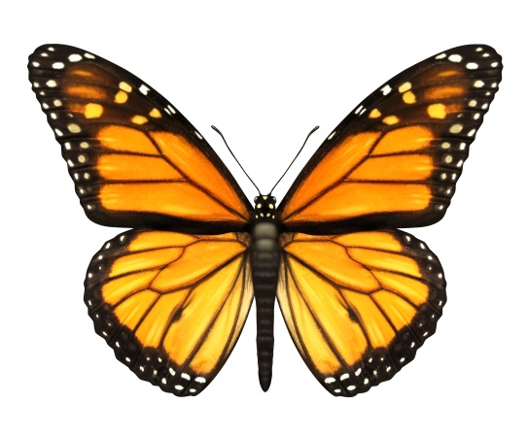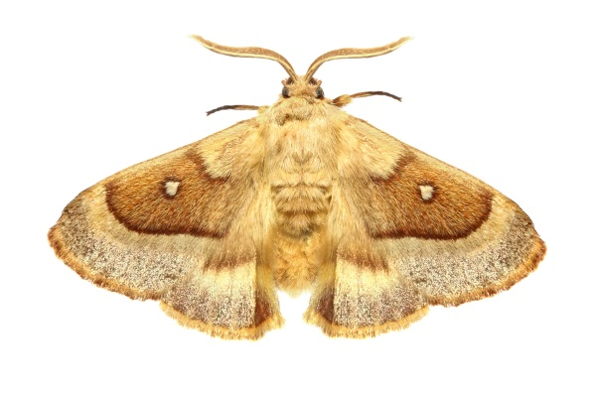

The table below lists some *differences* between butterflies and moths.

|  |  |  |
| --- | --- | --- |
| CHARACTERISTIC | Butterflies | Moths |
| Antenna shape | Clubbed/lump on end | Feathery antennas that are not clubbed at the end |
| Wing structure | 4 separate wings | Wings are linked together by bristle-like structures |
| Resting posture | Wings closed | Wings open |
| Forelegs | Smaller or missing forelegs | Fully developed forelegs |
| Active | Daytime | Night time |
| Colours | Usually bright colours | Usually dull colours |
| Cocoon or chrysalis | Chrysalis | Cocoon |

Both cocoons and chrysalis start as a caterpillar larva that eats the leaves of plants. When it is ready, both form a protective covering when they become a pupa (the stage between larva and adult).

1 A moth makes a silken cocoon whereas a butterfly makes a hard smooth chrysalis. What is an exoskeleton?

2 Both butterflies and moths are classified as insects. How can you tell the difference between insects and spiders?

3 Use the information provided on the previous page to draw the life cycle of a butterfly or a moth.

|  |
| --- |
|  |

4 Use the characteristics in the table to draw a butterfly and a moth. Label the similarities and differences between them.

|  |  |
| --- | --- |
| **BUTTERFLY** | **MOTH** |

WORD DETECTIVE

5 Secret message

Use words from the student book to work out the secret message below:

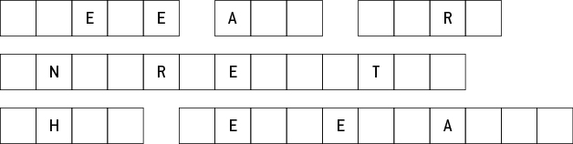

Literacy support worksheet

5.7 Vertebrates can be organised into five Classes

Pages 92–93 and 197

Classifying vertebrates

There are many different types of animals on Earth. The classification system is a way of ordering all the life forms so that we may better understand them. The kingdom is a large grouping; it can be broken down into a smaller grouping called a phylum. All the animals with a backbone or spinal column are in the Phylum Chordata. These animals are commonly known as vertebrates.

1 Using your student book, list the five classes of vertebrates.

2 Decide whether each of the following statements is true or false.

a A kingdom is a bigger group than a phylum. \_\_\_\_\_\_\_\_\_\_\_\_\_\_\_\_\_\_\_\_

b All animals in Class Aves lay eggs. \_\_\_\_\_\_\_\_\_\_\_\_\_\_\_\_\_\_\_\_

c A cat is a endotherm. \_\_\_\_\_\_\_\_\_\_\_\_\_\_\_\_\_\_\_\_

d Turtles belong to Class Amphibia. \_\_\_\_\_\_\_\_\_\_\_\_\_\_\_\_\_\_\_\_

e A frog is an example of a reptile. \_\_\_\_\_\_\_\_\_\_\_\_\_\_\_\_\_\_\_\_

3 Describe what determines whether an animal is a vertebrate or an invertebrate.

4 What are the tree subgroups of Class Mammalia? What is the feature used to separate these subgroups?

5 Below is a table of vertebrates. Highlight similar characteristics in the same colour.

Phylum Chordata (vertebrates)

|  |  |  |  |  |  |
| --- | --- | --- | --- | --- | --- |
| Class | Body cover | Reproduction | Breathing | Body temperature | Common name |
| Aves | Feathers | Eggs | Lungs | Endotherm | Birds |
| Pisces | Moist scales | Eggs | Gills | Ectotherm | Fish |
| Mammalia | Skin with hair or fur | Mostly live young | Lungs | Endotherm | Mammals |
| Reptilia | Moist scales | Eggs | Lungs | Ectotherm | Reptiles |
| Amphibia | Moist skin | Eggs | Gills and lungs | Ectotherm | Amphibians |

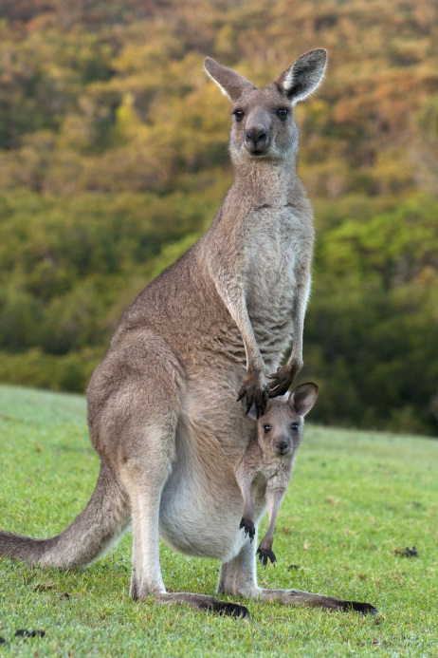 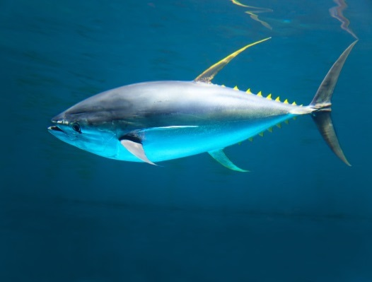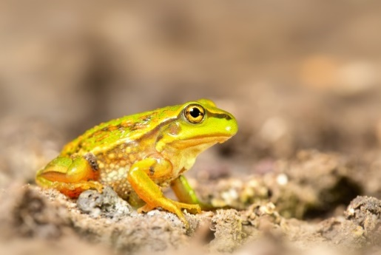

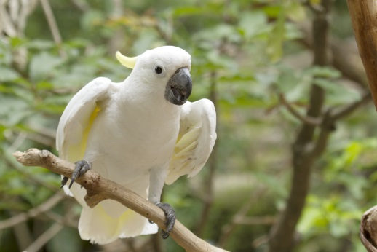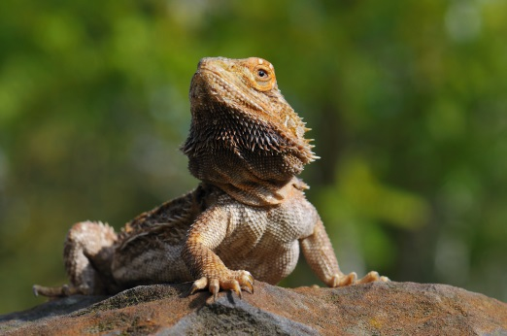

WORD DETECTIVE

7 True or false?

Read the statements below and circle whether each one is T for True or F for False.

a Invertebrates have a backbone T or F

b Dolphins are mammals T or F

c Birds are warm blooded T or F

d Fish are in the family Pieces T or F

Literacy support worksheet

5.8 Plants can be classified according to their characteristics

Pages 94–95 and 198

Plants from the dinosaur age

in 1994, a bushwalker in the Wollemi National Park (just north of Sydney), noticed some large trees that he thought were different to any others he had seen before. He carefully removed a small branch and took it to a friend who was a botanist (expert in the study of plants). Initially the botanist thought the branch looked like leaves that could be found on a fern, and was surprised to be told it was from a tree that was 40 metres tall.

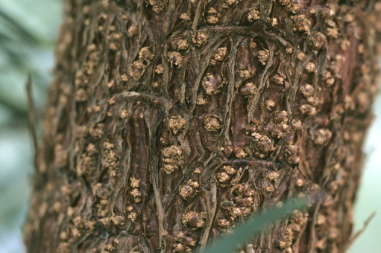Careful studies of the tree revealed that it was very similar to the types of trees that existed millions of years ago. The tree was named *Wollemi nobelis* after the Wollemi National Park (where it was found) Mr William Nobel (the bushwalker who found it).

1 The bark of the Wollemi pine, below, was once described as looking like it was ‘covered in coco pops’. Can you use more scientific terms to describe what it looks like?

2 Wollemi pine trees have large seeds that look like wings. How could these seeds be spread into new areas?

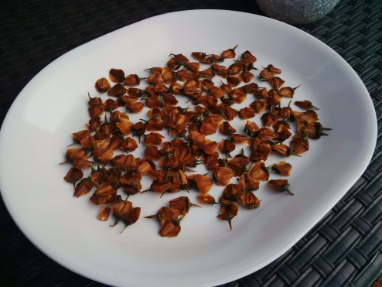

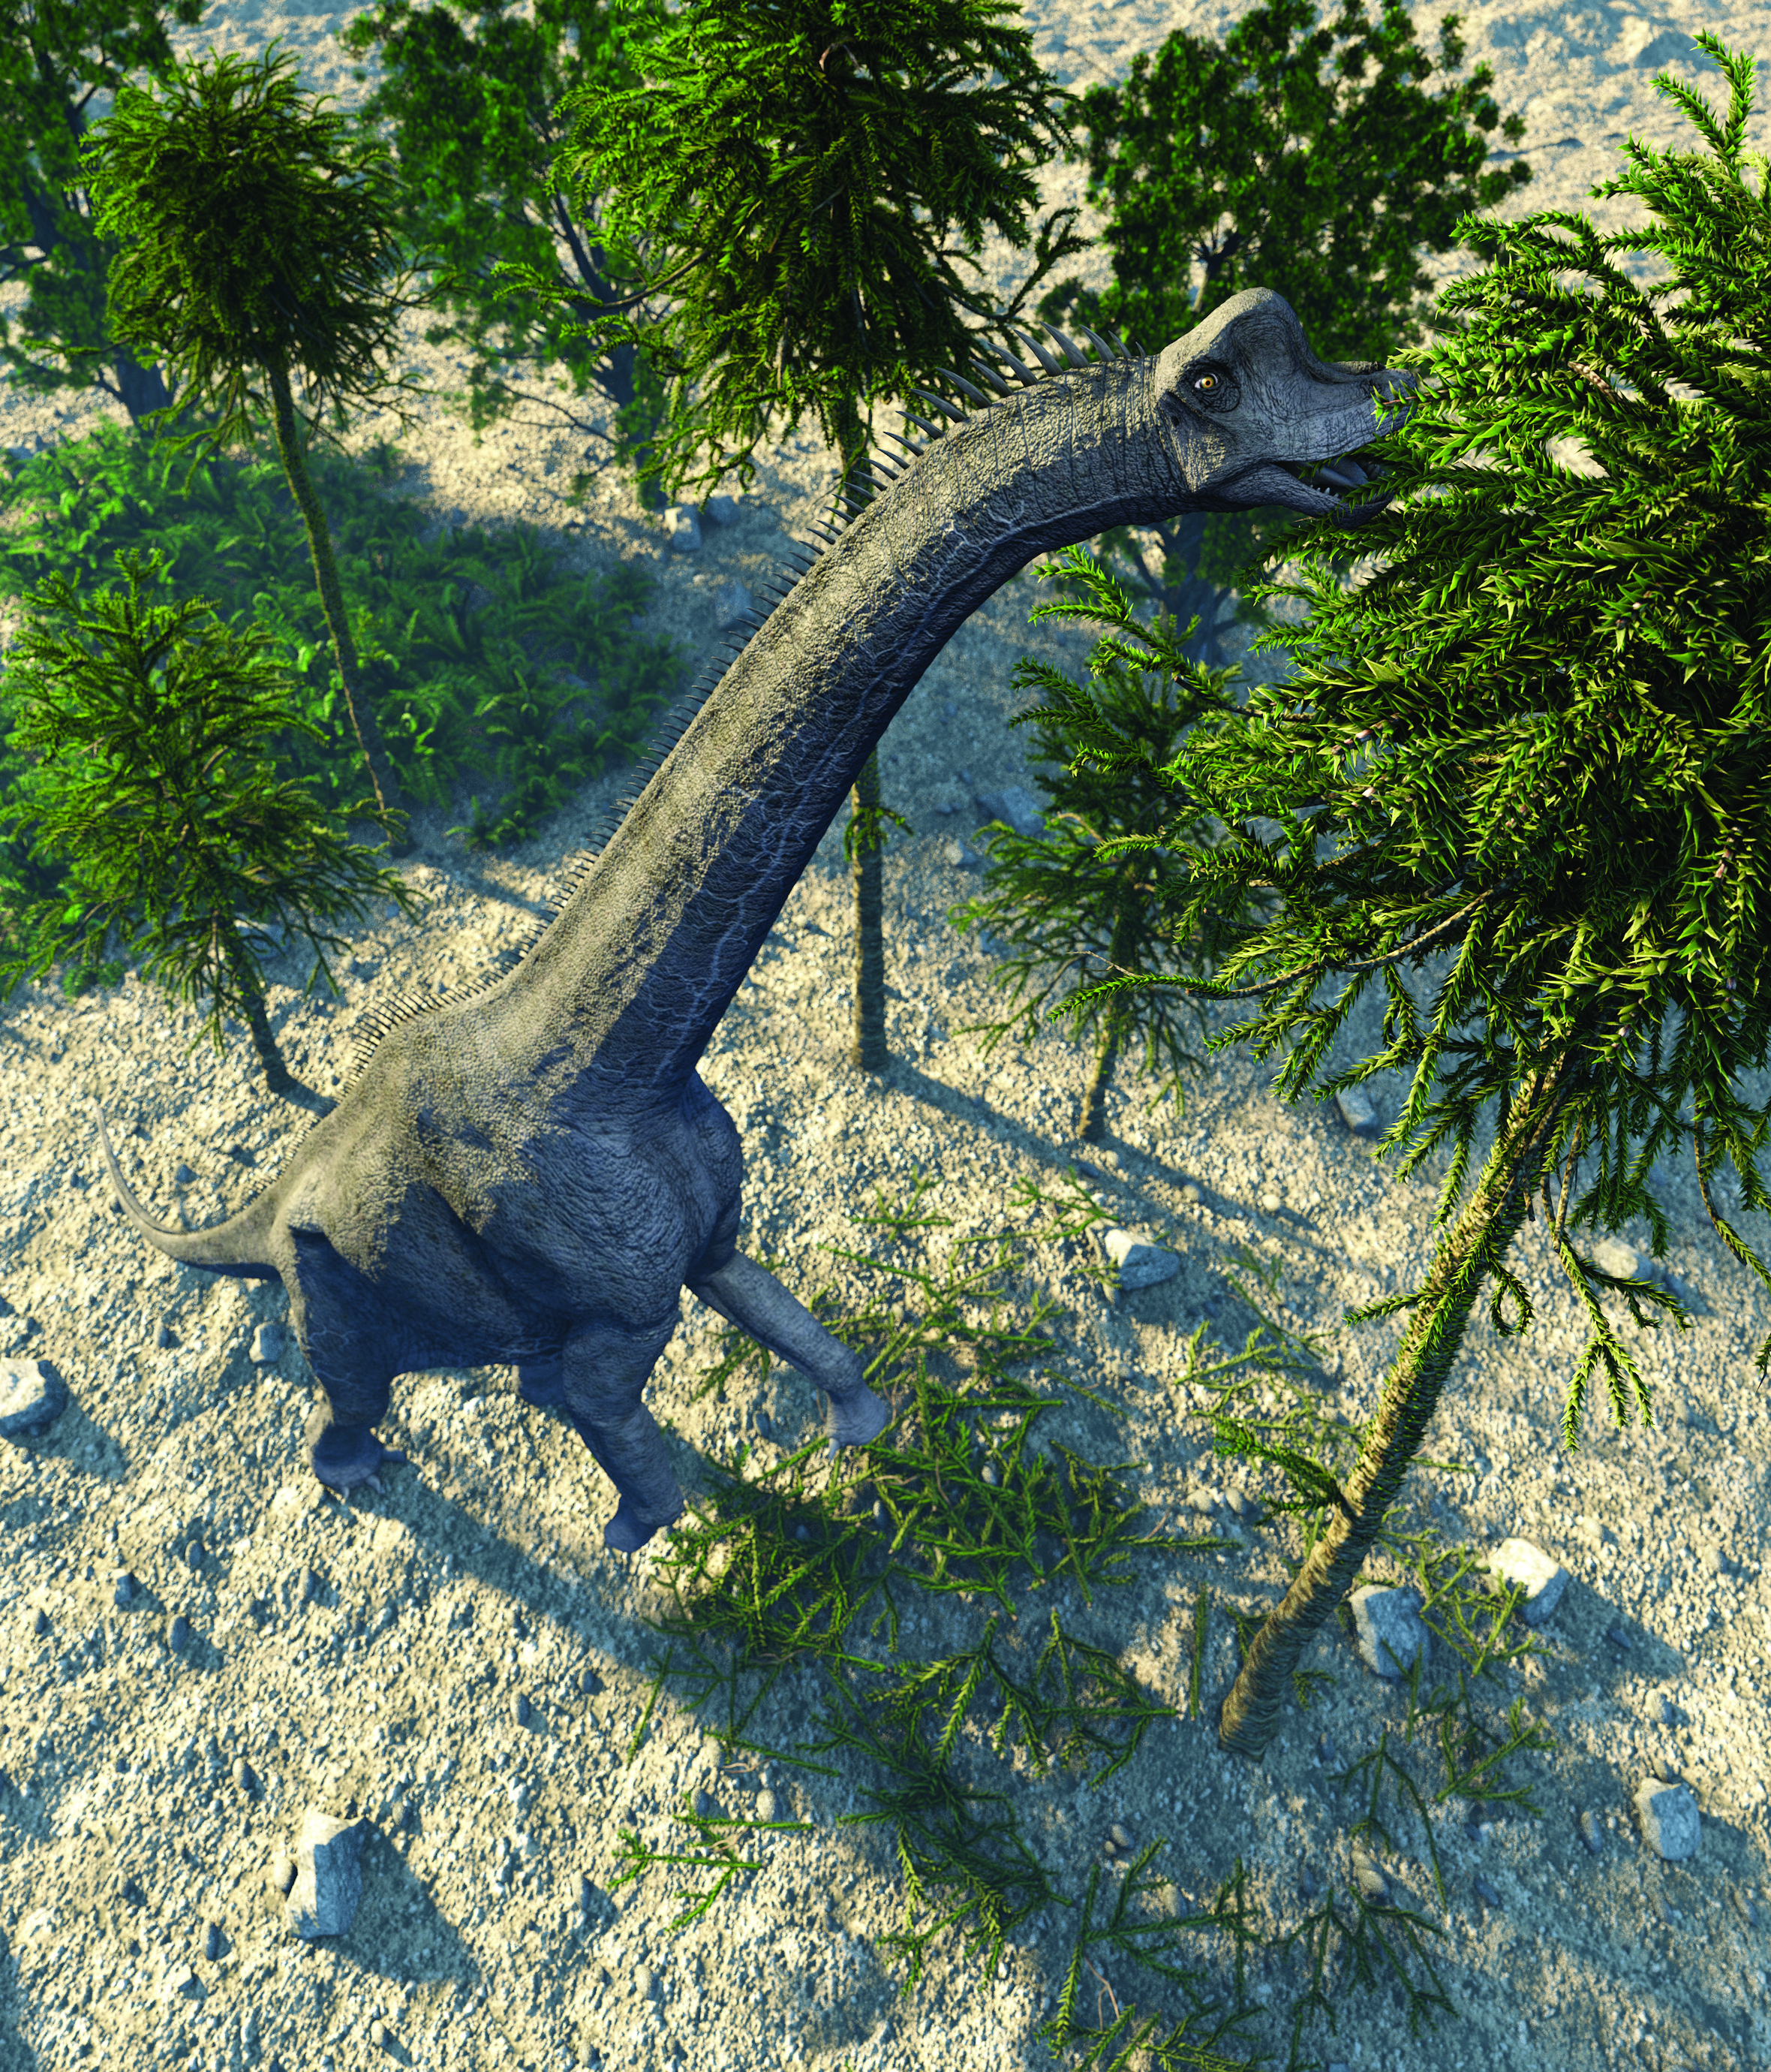3 a How might the Brachiosaurus (the dinosaur pictured) help with spreading the Wollemi pine seeds? (Look at what the Brachiosaurus is doing.)

b What might the Brachiosaurus provide to help the Wollemi pine seeds grow? (Think about what we add to plants to give them nutrients to help them grow).

4 Why is it important for seeds to move away from the parent tree before growing?

WORD DETECTIVE

5 Crossword

Use the clues below to complete the crossword.

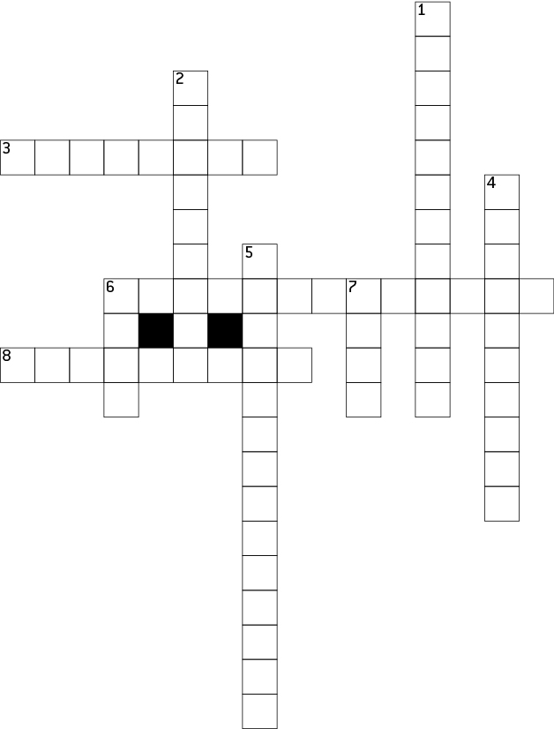

|  |  |
| --- | --- |
| **ACROSS**  3 Plant tissues that have an xylem and a phloem  6 Tree-eating dinosaur  8 Food, vitamins and minerals that plants need | **DOWN**  1 Plant tissues that have no xylem or phloem  2 To deposit pollen on a plant for fertilisation  4 Scientist that studies nature  5 The process in which the Sun’s energy is used to convert carbon dioxide and water into oxygen and sugars  6 The outside covering of a tree  7 Contains a plant embryo |

Literary support worksheet

5.9 The first Australian scientists classified their environment

Pages 96–97

Aboriginal medicines

|  |  |
| --- | --- |
| Early Australian scientists tested plants used by Aboriginals to see if they could be used for medicine. | |
| WS0523_00876-rf | Tea tree oil (Melaleuca alternifolia)  Tea tree oil was prepared by crushing the bark or leaves of the tea tree. The resulting oil or paste can be used to kill some fungal or bacterial infections, such as athlete’s foot, cold sores or skin infections. |
| WS0524_00876 | Kakadu plum (Terminalia ferdinandiana)  This fruit has 50 times more vitamin C than an orange. Vitamin C has been found to boost immune system function. |

|  |  |
| --- | --- |
| WS0525_00876-rf | Emu bush (Eremophila sp.)  Indigenous communities have used pastes made with the leaves of this plant to wash cuts and scrapes. Research so far shows that the leaves of the emu bush may be able to kill microorganisms such as bacteria. |
| WS0526_00876-rf | Eucalyptus (Eucalyptus sp.)  Kino is a red-coloured sap or gum that has been tested by scientists for its ability to kill bacteria. Indigenous communities used kino to treat burns, eye infections and toothache.  Early scientists would rub a small amount on their skin to test it. They could have tested it in their mouths, but it may not have been safe. |

1 When testing a plant for the first time, early scientists did not put it in their mouth. Instead they would rub a small amount on their skin. Suggest one reason why they tested plants in this way.

2 Why would scientists prefer to use the scientific names for the plants rather than their traditional names?

WORD DETECTIVE

3 Fill in the gaps

Read the information below and fill in the gaps using the words below.

|  |
| --- |
| hunting arid classified traditional food |

Australia’s \_\_\_\_\_\_\_\_\_\_\_\_\_\_\_\_\_\_\_\_\_ zone receives less than 250 millilitres of rainfall per year. The \_\_\_\_\_\_\_\_\_\_\_\_\_\_\_\_\_\_\_\_\_\_\_\_\_\_\_\_ owners of the land, the Anangu people knew where to find \_\_\_\_\_\_\_\_\_\_\_\_\_\_\_\_\_\_\_\_\_\_\_\_\_\_\_\_\_\_\_\_ to survive. They also knew which areas were the best for \_\_\_\_\_\_\_\_\_\_\_\_\_\_\_\_\_\_\_\_\_\_\_\_\_and gathering. The Anangu people \_\_\_\_\_\_\_\_\_\_\_\_\_\_\_\_\_\_\_\_ their environment in their own language to help them locate the precious food.